FaheeM Kathrada

IMMEDIA ASSESSMENT

Contents

**DB CREATION** 2

**API GUIDE** 2

**FRONT END** 3

Search Screen 3

# **DB CREATION**

1. The DB_Creation.sql must be executed first on your instance of SQL Server.
2. I have included a file IMMEDIA.bak in the event you want to just load the database from a file

# **API GUIDE**

I have opted to use the 4Square platform to carry out this assessment.

1. Ensure to change the web.config connection string to point to your instance of SQL. Enter your sql username and password accordingly. This needs to be done in the “Presentation” project.
2. Ensure to change the app.config connection string to point to your instance of SQL. Enter your sql username and password accordingly. This needs to be done in the “Data” project.
3. The API has route attributing, the route prefix is “AddressURL/api/foursquare/ENDPOINTNAMEHER/PARAMETERVALUES”
   1. Get a list of recommended venues based and on area name that has been passed into the endpoint:  
      AddressURL/api/foursquare/getvenuerecommendations/{venuename}
   2. Get a list of photos based on a venue:  
      AddressURL/api/foursquare/ getphotosbyvenueid/{venueid}
   3. Get details of a photo based on a photo id:  
      AddressURL/api/foursquare/ getphotodetails/{photoid}
   4. Get data from the database based on a specific photo:  
      AddressURL/api/foursquare/ getphotodetailsbyphotoid/{photoid}
4. The web.config holds the client key and secret key that is required to make use of 4Square platform.

# **FRONT END**

I have gone to create a front end as an extra option, just so that I could see actual data rather then seeing a bunch of data via postman that is meaningless.

The front end makes use of Sammy.js that ensures the front end is a SPA Application.

## Search Screen

1. Ensure you enter a place to search data for.
2. In the event of an error an error message will be displayed – Figure 2
3. If data does exist, then is will be displayed as per figure 3.
4. Click on a tile and this will then bring up images for then venue – Figure 4
5. Click on the image to view details for the image – Figure 5.

Figure 1

  
Figure 2  
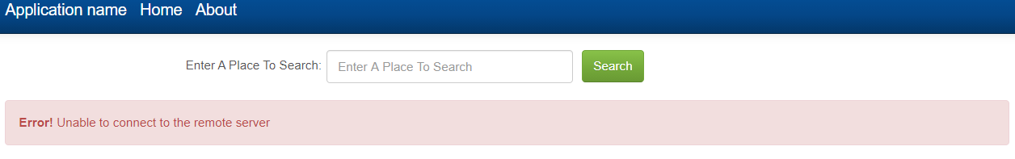

Figure 3

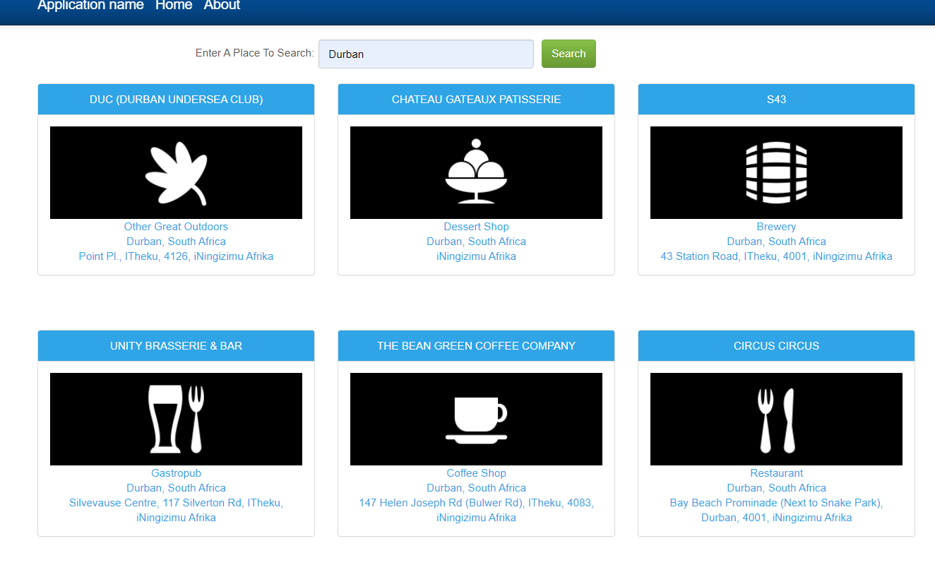

Figure 4

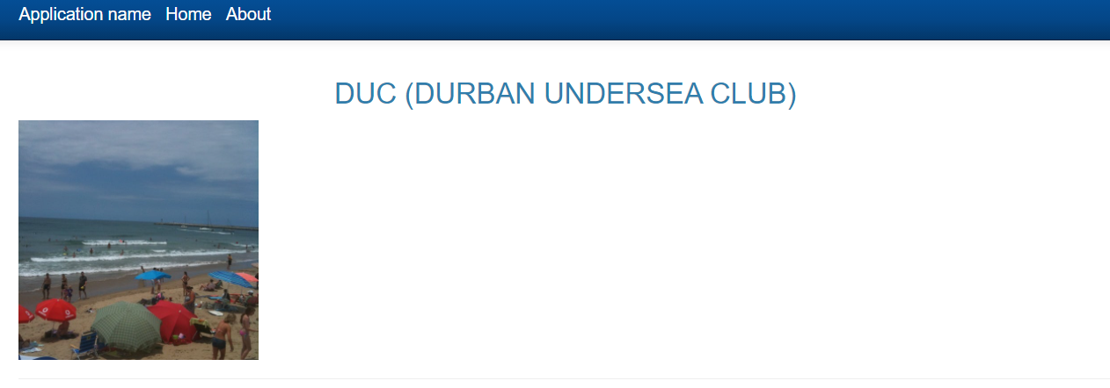

Figure 5

